Opening Ceremony

The Sergeant at Arms called the meeting to order and secured the quarters at 1830.

The colors were posted and the Pledge of Allegiance to the Flag was rendered.

The Chaplain led out in prayer.

Roll Call of Officers
Commandant |  | Wes Edmunson | Present
Senior Vice Commandant |  | Lynnnoi McCormick | Present
Junior Vice Commandant |  | Troy Carroll | Present
Judge Advocate |  | Anthony Nohmy | Excused
Adjutant |  | Sherry McGinnis | Present
 |  | Frank Garcia | Present
Paymaster |  | Hank Peralez | Present
Sergeant at Arms |  | Max Austgen | Excused
 |  | Mark Bylund | Excused
Chaplain |  | Bill Knipper | Present
 |  | Sherry McGinnis | Present
Color Sergeant |  | Andrew Thompson | Present
 |  | Teena Barna | Present
Web Sergeant |  | Jon-Michael McCormick | Present
Chief of Staff |  | Paul Bowen | Excused
Junior Past Commandant |  | Dan O’Connell | Present
Membership
Applications for Membership | Eric Bonner – DD214 to Adjutant and payment to Paymaster
Balloting of Membership | NA
Ceremony of Initiation, Introduction of New Members and Guests | NA

Report of Officers
Adjutant | Minutes of the previous meeting are on the Detachment’s website at gnd186mcl.org  - Motion made, seconded, and passed to accept the previous meeting’s minutes
Paymaster | Checking account  - Incoming ball and golf tournament expenses pending  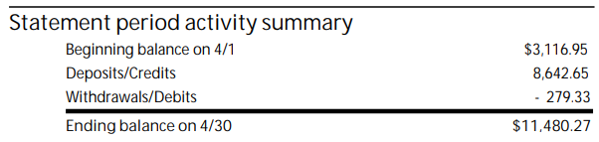  Savings account  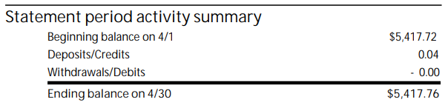  Motion made, seconded, and passed to accept.
Chaplain | Report of any member or member’s family sick or in distress  - Deon Wilson – Good days and bad days; undergoing tests for liver transplant  - Hector Gonzalez – Accident, recovering  - Dave Jochman and Mrs. Jochman – both better  - Todd Topham – Better and out of the hospital  - Mike Harvey – In the hospital
Sergeant at Arms | Anyone awaiting membership cards, please check with the table in the back
Color Sergeant | NA
Web Sergeant | NA
Chief of Staff | NA
Junior Past Commandant | Department Convention  - Dan O’Connell, Department Commandant  - Lynnnoi McCormick, Department Senior Vice Commandant  - Paul Bowen, Department Judge Advocate  - Max Austgen, Department Sergeant at Arms  SW Division Convention  - Jim Loorya, National Vice Commandant  - Roger Smith, National Senior Vice Commandant
Judge Advocate | Recommendations for changes to our bylaws were posted on our website with last month’s minutes. These changes were recommended to bring us in line with National bylaws and were reviewed by the Board of Officers. Are there any discussions before we vote on these bylaw changes?  Motion made, seconded, and passed to accept.
Junior Vice Commandant | NA
Senior Vice Commandant | Will not be running for the upcoming year. Please think of nominees for the position of Detachment Senior Vice Commandant.
Commandant | Will not be running for the upcoming year. Please make any nominees to Dan O’Connell.

Report of Standing/Special Committees

If anyone would like to help and be a part of any Committee, please reach out to a Detachment Officer
Golf Committee | The Legacy Golf Club  Saturday, 10 September  1330 shotgun  1800 dinner  $130 per player  $40 dinner only  - Can use Detachment’s help to find sponsors and players
Ball Committee | Marine Corps Birthday  Thursday, 10 November  The Leatherneck Club  Pre-Ball Party  Friday, 11 November  The Leatherneck Club  Birthday Ball  Saturday, 12 November  The Orleans Hotel & Casino  - 35% seats sold
Membership Activities Committee | NA
Nomination Committee | Dan O’Connell to head Committee

Business
Unfinished Business | Vote to move town halls to the 1st or 4th Sunday morning of the month before The Leatherneck Club opens at 1100  - Board of Officers have decided to keep meeting day and time as is
Good of the League | Ghost suggested fundraiser at The Leatherneck Club. Detachment officers as servers and bartenders. Date and time to be determined.  - Motion made, seconded, and passed to accept.
Announcements | Memorial Day Events  - Flag Placement  Southern Nevada Veterans Memorial Cemetery  28 May 0630  - Honor the Fallen – Lay Flags  Southern Nevada Devil Pups and Youth Leadership Authority  Southern Nevada Veterans Memorial Cemetery  28 May 0700 – 0900  - Memorial Day Service  Palm Northwest Mortuary & Cemetery  28 May 1000  - Memorial Day Service  Greater Nevada Detachment 186  Southern Nevada Veterans Memorial Cemetery  30 May 1000  - Honor the Fallen – Retrieve and Roll Flags  Southern Nevada Devil Pups and Youth Leadership Authority  Southern Nevada Veterans Memorial Cemetery  30 May 1300 – 1700  The Summerlin Council Patriotic Parade  Monday, 04 July (time to be determined)  - Looking for participants to be in the parade representing different eras of the Marine Corps  NVOAF Fundraising Banquet  Gold Coast Casino  Saturday 16 July 2022  NVOAF.org to purchase tickets and raffle tickets  Table of 10 seats  - Early bird $750  - After July $1000  Individual Seats  - Early bird $75  - After July $100  BJ’s Restaurant Fundraiser  Wednesday, 01 June 1730 – 2030  10840 West Charleston, Summerlin  - Flyer must be presented to wait staff  - Will be placed on Facebook for anyone who would like to print on their own  Young Marines  - Looking for volunteers  - 3 adult volunteers  - Pass background check  - Must be able to attend 2 meetings each month  News and Announcements – Check our website at www.gnd186mcl.org  - News and announcements are on our Bulletin page  - Calendar items are on our Events page  Friday social night

Closing Ceremony

Motion to close the meeting made and seconded. Motion carried.

Next meeting will be on 23 June 2022.

Colors secured. Closing prayer. Meeting closed 1909.

